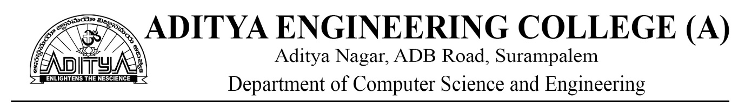

**Academic Year:** 2022-23 **Program Name: B.Tech**

**Subject: Artificial Intelligence**

**Unit wise short and long answer question bank**

**UNIT-1**

**SHORT ANSWER QUESTIONS**

1. Define Artificial Intelligence?
2. What is Intelligent Systems?
3. Give real life examples of AI?
4. What is the first intelligent system? Explain it?
5. What are various AI languages?
6. Explain about Tic-Tac- Toe Game Playing?

**LONG ANSWER QUESTIONS**

1. What are the intelligent systems? Give examples.
2. Write the history of artificial intelligence in brief.
3. Explain the components of AI.
4. Write briefly the foundations of AI.
5. Explain the applications of AI.
6. Describe about AI languages.
7. What are the current trends in AI?

**UNIT-2**

**SHORT ANSWER QUESTIONS**

1. What is the use of heuristic functions?
2. State the advantages of Breadth First Search?
3. What is the difference between BFS and DFS?
4. What is the purpose of A* algorithm?
5. How problem reduction works in AI?
6. Write examples for heuristic Search Techniques?

**LONG ANSWER QUESTIONS**

1. What are the general problem-solving techniques?
2. Describe the Missionaries and Cannibals problem using production system.
3. Explain the water jug problem.
4. Describe with an example about depth first search algorithm.
5. Compare forward chaining and backward chaining.
6. What are the problems in hill climbing? How will you solve it?
7. Explain the best first search algorithm.
8. Describe A* algorithm.
9. What is problem reduction? Give an example.
10. What is alpha beta pruning? How it is different from minmax algorithm? Explain with an example.
11. Solve using constraint satisfaction: (i) S E N D + M O R E = M O N E Y

(ii) B A S E + B A L L = G A M E S.

**UNIT-3**

**SHORT ANSWER QUESTIONS**

1. What is propositional logic? Explain?
2. What is propositional calculus?
3. Explain natural deduction system?
4. What is the purpose of semantic tableau system in propositional logic?
5. Explain resolution refutation in propositional logic?
6. What is the role of predicate logic in AI?

**LONG ANSWER QUESTIONS**

1. What is propositional logic? Give any two examples.
2. What is logic? Define well-formed formula.
3. Draw the truth table using propositional logic: ((A ® B) L A) ® B.
4. Explain the Axiomatic System for Propositional Logic
5. Discuss about Disjunctive & Conjunctive Normal Forms
6. What is resolution refutation method? Outline the conversion formula in propositional logic to transform into its equivalent CNF representation?
7. Explain about predicate logic in detail?

**UNIT-4**

**SHORT ANSWER QUESTIONS**

1. What is Knowlwedge Representation in AI?
2. List the types of approaches in knowledge representation?
3. What is semantic network?
4. What are various types of relations in semantic network?
5. What is frame for knowledge representation?
6. Explain extended semantic network?

**LONG ANSWER QUESTIONS**

1. Explain about various approaches to knowledge representation.
2. Explain semantic network with suitable examples.
3. Explain Frame network for knowledge representation with suitable examples.
4. Explain extended semantic network for knowledge representation with suitable examples.

**UNIT-5**

**SHORT ANSWER QUESTIONS**

1. What is expert system?
2. List out the phases in building expert system?
3. What is the difference between expert system versus traditional systems?
4. Lost out application of expert systems?
5. Explain Bayesian belief networks?
6. Explain certainty factor theory?
7. Explain the role of code generator in a compiler?

**LONG ANSWER QUESTIONS**

1. Explain in brief about phases in building expert systems with a neat diagram.
2. Explain the differences between expert system and traditional systems?
3. Explain in detail about rule-based expert systems.
4. What are various application of expert systems.
5. Explain about bayesian belief networks with suitable example?
6. Explain about certainty factor theory.
7. Explain dempster- shafer theory.